SmallWorlds

Adventure and Mayhem in Smalltalk

Bob Jarvis
March, 2001
Table of Contents

Legal Notice 1
Creating An Adventure 2
SmallWorlds Classes 3
Actor 3
Action 4
CommandParser 4
Connection 4
Container 4
DarkLocation 4
Describable 4
ForwardingLocation 4
ImmovableItem 5
Item 5
LightSource 5
Location 5
ReflectingLocation 5
Response 5
SimpleActor 5
SimpleCommandParser 5
TerminalLocation 5
Treasure 5
World 5
Notes 6
Dolphin Smalltalk 6
Installation 6
Testing 6
Porting 6
Colossal Cave 6
Contacting The Author 7

Legal Notice

Copyright © 2001 Robert Jarvis

Permission is hereby granted, free of charge, to any person obtaining a copy of SmallWorlds and associated documentation files (the “Software”), to deal in the Software without restriction, including without limitation the rights to use, copy, modify, merge, publish, distribute, sublicense, and/or sell copies of the Software, and to permit persons to whom the Software is furnished to do so, subject to the following conditions:

The above copyright notice and this permission notice shall be included in all copies or substantial portions of the Software.

THE SOFTWARE IS PROVIDED “AS IS”, WITHOUT WARRANTY OF ANY KIND, EXPRESS OR IMPLIED, INCLUDING BUT NOT LIMITED TO THE WARRANTIES OF MERCHANTABILITY, FITNESS FOR A PARTICULAR PURPOSE AND NONINFRINGEMENT. IN NO EVENT SHALL THE AUTHORS OR COPYRIGHT HOLDERS BE LIABLE FOR ANY CLAIM, DAMAGES OR OTHER LIABILITY, WHETHER IN AN ACTION OF CONTRACT, TORT OR OTHERWISE, ARISING FROM, OUT OF OR IN CONNECTION WITH THE SOFTWARE OR THE USE OR OTHER DEALINGS IN THE SOFTWARE.

This software is OSI Certified Open Source Software.
OSI Certified is a certification mark of the Open Source Initiative.

Creating An Adventure

Text adventure games (TAGs) are one of the classic forms of computer entertainment software. In a TAG there are locations to move between, creatures to encounter and interact with, treasures to be gained, puzzles to solve, and interesting ways to get killed. Some examples of this genre include the games published by Infocom fifteen years ago (including the Zork series, Planetfall, and others), and the classic Colossal Cave adventure. A version of Colossal Cave is included with this software.

SmallWorlds is an object-based construction set for building your worlds, as opposed to script-based engines such as the various tools which use the Infocom “Zork” language. This is intentional, as the motivation for writing SmallWorlds was to provide a demonstration of good object-oriented development practices, as well as to have some fun.

Following are some suggested steps to follow when creating your own adventures:

- Write up a description of the world. Include such things as creatures to be encountered, puzzles to be solved, and such. Remember that in text adventures combat is boring, relatively random, and adds little to the game. The use of puzzles, locks-and-keys, and such makes the game more interesting.
- Create a map of your world. Give names to important locations, such as those that contain monsters, treasures, or puzzles. Determine how the locations are connected.
- Write descriptions for each location.
- Create a subclass of World for your new adventure. Override #initialize to perform whatever steps are necessary to get your world ready for play. See ColossalCaveWorld>>initialize for examples.
- Create a subclass of SimpleActor for the actor in your world.
- Create a subclass of AdventureShell to serve as the user interface for your world. Override the class #defaultModel method to answer the name of your World subclass. (See ColossalCaveShell for example).
- Evaluate “YourWorldShell show” in a workspace to start a new user interface connected to an instance of your World subclass.
- Write code needed to handle special occurrences in your world. Commonly you’ll override Actor methods in your SimpleActor subclass (created in step 5) to handle special cases. You may also need to subclass Location so your can override #receiveActor:, or you may need to add code elsewhere for other special circumstances.
- Iterate these steps until you’re satisfied.

SmallWorlds Classes

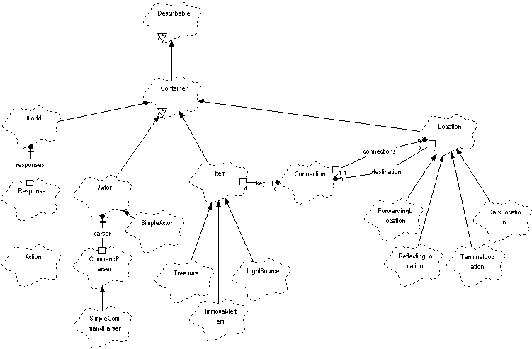

Actor
An object that is capable of processing commands. The following diagram illustrates how commands are processed by Actor:
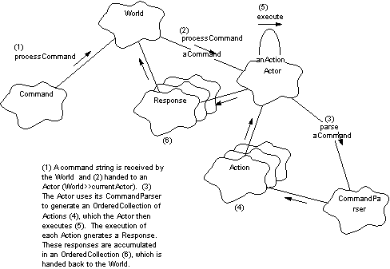

Action
An individual action which an Actor can execute.

CommandParser
Parses a command string, producing a collection of Actions that an Actor can execute.

Connection
Represents a connection from one location to another. Connections are one way only - to have a bi-directional connection between Locations each Location must have a Connection leading to the other. Connections can optionally have a key object specified, in which case they can be locked and unlocked.

Container
Something in the world that can contain other things.

DarkLocation
A service subclass of Location that is created with its lighted attribute set to false.

Describable
Something which has a description. There are two description styles available, noun-phrase descriptions and text descriptions. Noun-phrase descriptions are most commonly used by Items, and text descriptions are commonly used by other objects (e.g. Locations).

ForwardingLocation
A location that receives an Actor, generates a response containing the description of the location, and forwards the Actor on to another location.

ImmovableItem
An item which cannot be picked up by an Actor.

Item
A 'thing' in the database which is not an actor (e.g. is passive, not active), e.g. lamp, key, rod, etc.

LightSource
An item which generates light. May be switched on or off.

Location
A place which can be visited. Has a collection of Connections to other Locations.

ReflectingLocation
A Location that generates a response containing its description then returns the Actor to its previous location.

Response
The response from a command. Useful for maintaining a history of what has happened. Contains Strings such as 'The door is unlocked', 'The lamp is now lit', 'You are in a maze of little rooms, all alike', etc. Generally speaking Responses should only be answered by methods in Actor or its subclasses.

SimpleActor
A subclass of Actor which uses a SimpleCommandParser to parse commands.

SimpleCommandParser
A command parser which can understand simple commands of up to two words, such as
go north --> Action new verb: #move with: #('north')
south --> Action new verb: #move with: #('south')
get anItemName --> Action new verb: #get with: #('anItemName')
Verbs should be implemented as messages by Actors.

TerminalLocation
A location which kills Actors which move into it.

Treasure
Items for which the player gets points.

World
The container for all things in an adventure.

Notes

Dolphin Smalltalk

Installation
- Unzip the archive into a directory, then install the SmallWorlds package. You can also install the ColossalCaveWorld package if you want to.

Testing
To run the test world evaluate the following in a workspace:

AdventureShell show

To run the version of the Colossal Cave adventure included in the ColossalCaveWorld package evaluate the following in a workspace:

ColossalCaveShell show

Porting
Files for each of the classes in the framework are supplied in chunk format. You may need to edit these by hand to remove any lines that your version of Smalltalk won’t accept, and then file them in. The only non-standard Smalltalk feature used is the code which saves and restores a World (see World>>save and World>>restore) which makes use of the Dolphin STB (Smalltalk Binary Filing) classes. Most Smalltalk implementations provide some way of saving and restoring objects to/from flat files, and you should use whatever method your Smalltalk implementation provides. (The objective here is to provide a player of a particular implementation a way to save and restore his position in a World; there is no intent to create a cross-platform, cross-Smalltalk method of doing binary object filing). As far as the user interface goes, the original implementation is very simple – a text box is placed at the top of the window and is used by the player to enter commands which are passed to the World (World>>processCommand:). Below the input text box is a multiline text box that is used to display the Responses collected by the World.

Colossal Cave
The version of Colossal Cave supplied with this package is a partial implementation of the original Colossal Cave adventure. The wandering dwarves and the pirate were not implemented because I always disliked the random factor they introduced into the game, and in addition the end-game scenario wasn’t implemented. I also eliminated the requirement to kill the dragon, not from any desire to “sanitize” the game, but because at that point I was tired of programming the blasted thing and wanted to get done with it. A new way of “removing” the dragon was introduced, which will give experienced Colossal Cave players something new to figure out.

Contacting the Author

If you need to contact the author you can try the following:

- Post a message on comp.lang.smalltalk or comp.lang.smalltalk.dolphin. I usually monitor these groups, and if I’m not around someone else may be able to help you.
- Post a message on the Squeak mailing list, if you’re a member. If you’re not a member you should be – send an email to squeak-request@cs.uiuc.edu with the word “Subscribe” in the subject line to join. (Squeak, if you’re not familiar with it, is a free version of Smalltalk brought to you by some of the original Smalltalk developers from Xerox PARC. Alan Kay, Dan Ingalls, and several other very talented individuals make up Squeak Central at Disney, and they are aided and abetted by the members of the Squeak mailing list).
- Send email to jarvisb@timken.com or jarvis@nls.net. The first address will likely get you faster turnaround.

I’d be interested in hearing about what anyone is doing with SmallWorlds. Good luck, and have fun.

Bob Jarvis
March, 2001

